I
DESIGN AND 32-nm PHYSICAL IMPLEMENTATION OF A
HIGH-PERFORMANCE PIPELINED INT8 SYSTOLIC-ARRAY
AI ACCELERATOR
A Dissertation work submitted in partial fulfillment of the requirement
for the award of the degree of
MASTER OF TECHNOLOGY
In
VLSI DESIGN
By
[STUDENT NAME]
Regd.No: [REGISTRATION NUMBER]
Under the esteemed guidance of
[GUIDE NAME], M.Tech (Ph.D)
Assistant Professor
Department of Electronics and Communication Engineering
B V RAJU INSTITUTE OF TECHNOLOGY
(Approved by AICTE, New Delhi and Affiliated to JNTUH, Hyderabad)
Vishnupur, Narsapur, Medak. (Dist)-502313
2025-2026

II
B.V. RAJU INSTITUTE OF TECHNOLOGY
Vishnupur, Narsapur, Medak. (Dist.) Pin: 502313
(Affiliated to JNTU, Hyderabad)
Department of Electronics and Communication Engineering
CERTIFICATE
This is to certify that the Dissertation work entitled “Design and 32-nm Physical Implementation of a High-Performance Pipelined INT8 Systolic-Array AI Accelerator” is being submitted by [STUDENT NAME] in partial fulfillment of the requirement for the award of the degree of M.Tech in VLSI Design, B V RAJU INSTITUTE OF TECHNOLOGY, Narsapur, Medak, affiliated to Jawaharlal Nehru Technological University, Hyderabad, under my guidance and supervision.
The results presented in this major project have been verified and are found to be satisfactory.

Head of the Department | Internal Guide
[HOD NAME]  Professor and HOD  Department of ECE | [GUIDE NAME]  Assistant Professor  Department of ECE

External Examiner

III
ACKNOWLEDGEMENT
It has been a great privilege to be a postgraduate student of the Department of Electronics and Communication Engineering at B V RAJU INSTITUTE OF TECHNOLOGY, Narsapur. The academic environment, laboratory facilities, and constant support from the faculty have provided the necessary motivation to complete this dissertation work successfully.
I express my sincere gratitude to our college management and the Principal for providing the required infrastructure and facilities for carrying out the project work. I am also thankful to the Head of the Department for continuous encouragement, monitoring, and support during the execution of the project.
I would like to express my deep sense of gratitude to my internal guide, [GUIDE NAME], Assistant Professor, Department of ECE, for valuable guidance, suggestions, and technical support throughout the project. His/her guidance helped me understand the RTL design, synthesis flow, and physical implementation stages in a systematic manner.
I also thank all faculty members and non-teaching staff of the ECE Department for their direct and indirect support. Finally, I extend my heartfelt thanks to my family and friends for their constant encouragement and support throughout the completion of this project.

[STUDENT NAME]
([REGISTRATION NUMBER])

IV
DECLARATION
I hereby declare that the work presented in this project entitled “Design and 32-nm Physical Implementation of a High-Performance Pipelined INT8 Systolic-Array AI Accelerator” submitted towards completion of the major project in the second year of M.Tech in VLSI Design at B V RAJU INSTITUTE OF TECHNOLOGY, Narsapur, is an authentic record of original work carried out under the guidance of [GUIDE NAME], Assistant Professor, Department of ECE.
The matter embodied in this dissertation has not been submitted previously for the award of any degree or diploma in any other institution.

Place: Narsapur
Date: [DATE]

[STUDENT NAME]
[REGISTRATION NUMBER]

V
CONTENTS
Certificate | II
Acknowledgement | III
Declaration | IV
Abstract | XI
CHAPTER 1 : INTRODUCTION | 1-9
1.1 Introduction | 1
1.2 Artificial Intelligence Accelerators | 2
1.3 Matrix Multiplication in Machine Learning | 3
1.4 Need for Systolic Array Architecture | 4
1.5 Problem Statement | 5
1.6 Motivation and Objectives | 6-7
1.7 Expected Contributions | 8
1.8 Scope of the Project | 9
CHAPTER 2 : LITERATURE SURVEY | 10-19
2.1 Introduction to Literature Survey | 10
2.2 Review of Base Paper | 11-12
2.3 Existing Systolic Array Accelerators | 13-15
2.4 Processing Element Optimizations | 16
2.5 Pipelining in VLSI Datapaths | 17
2.6 Research Gap | 18-19
CHAPTER 3 : BASELINE ARCHITECTURE | 20-30
3.1 Baseline Accelerator Overview | 20
3.2 Processing Element Design | 21-22
3.3 8x8 Systolic Array Structure | 23-25
3.4 Register Interface and Control | 26
3.5 Limitations of Existing System | 27-30
CHAPTER 4 : PROPOSED METHODOLOGY | 31-50
4.1 Proposed Pipelined Design Approach | 31
4.2 Critical Path Analysis | 32-34
4.3 Pipelined Processing Element | 35-38
4.4 Array-Level Timing Modification | 39-40
4.5 RTL Verification Methodology | 41-43
4.6 SDC Constraint Methodology | 44-45
4.7 Design Compiler Methodology | 46-47
4.8 ICC2 Physical Design Methodology | 48-50
CHAPTER 5 : IMPLEMENTATION | 51-60
5.1 RTL Files Used | 51
5.2 Testbench Files Used | 52
5.3 DC Script Implementation | 53-55
5.4 ICC2 Script Implementation | 56-58
5.5 Checks after Implementation | 59-60
CHAPTER 6 : RESULTS AND DISCUSSION | 61-67
6.1 Result Parameters | 61
6.2 Synthesis Results | 62-63
6.3 Physical Design Results | 64-65
6.4 Baseline vs Proposed Comparison | 66-67
CHAPTER 7 : CONCLUSION | 68-70
7.1 Summary | 68
7.2 Future Scope | 69-70
REFERENCES | 71-72
APPENDIX | 73-78

IX
LIST OF FIGURES
Fig 1.1 RTL-to-GDSII project flow | 3
Fig 3.1 8x8 systolic array architecture | 23
Fig 3.2 Baseline processing element datapath | 22
Fig 4.1 Proposed pipelined processing element | 36
Fig 4.2 Accelerator data movement | 40
Fig 4.3 Accelerator control flow | 42
Fig 4.4 Design Compiler flow | 46
Fig 4.5 ICC2 physical design flow | 49
Fig 6.1 Critical path reduction by pipelining | 63
Fig 6.2 Expected ICC2 layout view | 65
Fig 6.3 Power, performance and area metrics | 66
Fig 7.1 Project execution plan | 70

XI
ABSTRACT
Artificial intelligence and machine-learning applications require a large number of arithmetic operations, especially multiplication and accumulation operations. Matrix multiplication is one of the most important computations used in neural-network inference, convolutional neural networks, and deep-learning accelerators. General-purpose processors are not always efficient for executing such repeated and parallel arithmetic operations. Therefore, dedicated hardware accelerators are widely used to improve computational performance.
This project presents the design and 32-nm physical implementation of a high-performance INT8 systolic-array AI accelerator. The baseline architecture consists of an 8x8 systolic array with 64 processing elements. Each processing element performs signed 8-bit multiplication and 32-bit accumulation. The accelerator is mainly designed for matrix-multiplication-based machine-learning workloads.
The main objective of this project is to improve the timing performance of the baseline systolic-array accelerator. In the baseline design, the multiplier and accumulator adder are present in the same combinational path inside the processing element. This increases the critical path delay and limits the maximum operating frequency. To overcome this limitation, a pipelined processing-element architecture is proposed. In the proposed design, a pipeline register is inserted between the multiplication stage and the accumulation stage. This divides the MAC operation into separate pipeline stages and reduces the critical path delay.
The RTL design is developed using Verilog HDL and verified using simulation testbenches. The baseline and proposed designs are synthesized using Synopsys Design Compiler with a 32-nm standard-cell library. Physical implementation is carried out using Synopsys ICC2, including floorplanning, placement, clock-tree synthesis, routing, and post-route timing analysis. The two designs are compared in terms of area, power, timing, maximum operating frequency, and physical layout quality.

CHAPTER 1
INTRODUCTION
1.1 Introduction
The rapid growth of artificial intelligence has increased the demand for high-speed hardware architectures that can execute repeated arithmetic operations efficiently. A large portion of modern machine-learning computation is dominated by multiply-accumulate operations. These operations appear in convolution, matrix multiplication, fully connected layers, and many signal-processing workloads. When these operations are executed using a general-purpose processor, the available parallelism is not fully utilized. This motivates the design of dedicated hardware accelerators.
An AI accelerator is a hardware block designed to perform a particular set of arithmetic operations faster and more efficiently than a general-purpose processor. In neural-network inference, 8-bit integer arithmetic is widely used because it provides a good balance between accuracy, area, and speed. INT8 arithmetic reduces storage requirements and simplifies multiplier hardware compared with floating-point arithmetic. Therefore, INT8 systolic-array accelerators are suitable for embedded and edge AI applications.
This project focuses on the design and implementation of an 8x8 INT8 systolic-array AI accelerator. The project starts from a baseline RTL design and improves its timing performance by introducing a pipelined processing element. The final design is targeted for a 32-nm ASIC design flow using Synopsys Design Compiler and Synopsys ICC2.
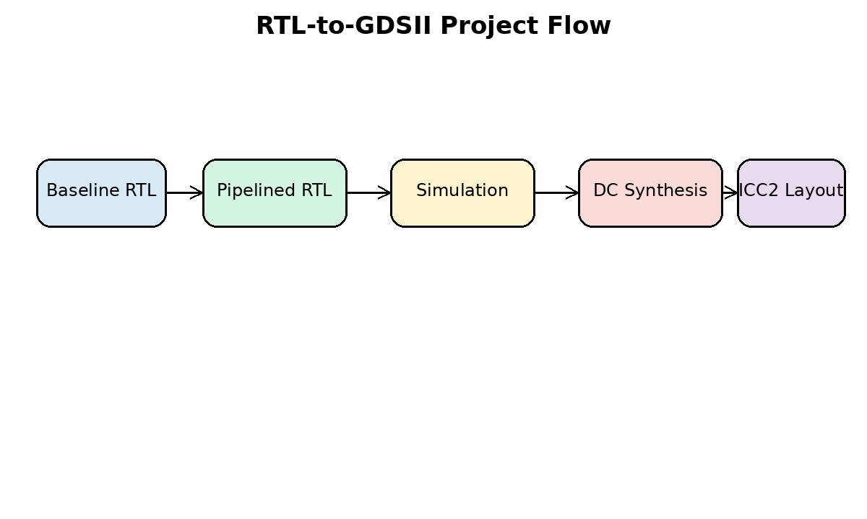
Fig 1.1 RTL-to-GDSII project flow
1.2 Artificial Intelligence Accelerators
AI accelerators are specialized hardware engines used to speed up machine-learning workloads. These accelerators may be implemented as GPUs, TPUs, DSP accelerators, FPGAs, or ASIC blocks. ASIC-based AI accelerators provide the best opportunity for optimized power, performance, and area because the architecture can be tailored to the computation pattern.
The most common operation in neural-network inference is the MAC operation. A MAC unit multiplies two operands and accumulates the result with previous partial sums. When thousands or millions of MAC operations are required, a parallel hardware architecture is necessary. Systolic arrays are among the most important structures used for this purpose.
Unlike a CPU, which executes operations sequentially or with limited SIMD parallelism, a systolic-array accelerator contains many small processing elements operating simultaneously. This improves throughput and reduces unnecessary data movement by passing values directly between neighboring processing elements.
1.3 Matrix Multiplication in Machine Learning
Matrix multiplication is the backbone of many machine-learning algorithms. In convolutional neural networks, convolution can be transformed into matrix multiplication using data rearrangement techniques. In fully connected layers, the output is obtained by multiplying the input activation matrix with the weight matrix. Transformer models also rely heavily on matrix multiplication for attention and feed-forward operations.
For two matrices A and B, the output matrix C is computed by multiplying rows of A with columns of B. Each output element is obtained by repeatedly multiplying corresponding elements and accumulating the partial products. This computation maps naturally to an array of MAC units.
In this project, the accelerator is designed for INT8 matrix multiplication. The operands are signed 8-bit values and the partial sums are accumulated using 32-bit registers. The use of 32-bit accumulation avoids overflow for typical INT8 matrix operations and provides sufficient precision for inference workloads.
1.4 Need for Systolic Array Architecture
A systolic array is a regular arrangement of processing elements connected in a grid. Data flows through the array in a rhythmic manner, similar to the pumping action of a heart. Each processing element performs local computation and forwards data to its neighboring elements. This regular communication pattern makes systolic arrays highly suitable for VLSI implementation.
The main advantages of systolic arrays are high parallelism, local interconnection, high data reuse, and scalable design. Since data is reused within the array, memory bandwidth requirements are reduced. Local interconnection also simplifies physical design compared with fully connected architectures.
The selected architecture uses an 8x8 systolic array containing 64 processing elements. After the pipeline is filled, multiple MAC operations can be executed in parallel every clock cycle. This makes the design suitable for high-throughput matrix multiplication.
1.5 Problem Statement
The baseline 8x8 INT8 systolic-array accelerator has a processing element in which multiplication and accumulation occur within the same combinational path. The critical path includes the signed multiplier, sign extension logic, 32-bit adder, and accumulator register setup time. This long path limits the maximum operating frequency of the accelerator.
For high-performance ASIC implementation, the critical path must be reduced. A shorter critical path allows the design to meet tighter clock constraints and improves the maximum frequency. Therefore, the problem addressed in this project is the timing limitation caused by the long MAC datapath inside the processing element.
The proposed solution is to pipeline the processing element by inserting a register after the multiplier. This separates multiplication and accumulation into two stages and reduces the delay of each clock cycle.
1.6 Motivation and Objectives
The motivation for this project is to improve the timing performance of an AI accelerator using a practical VLSI design technique. Pipelining is one of the most widely used methods to improve throughput and maximum operating frequency in digital systems. By applying pipelining at the processing-element level, the timing performance of the complete systolic array can be improved.
The objectives of the project are to study systolic-array accelerators, understand the baseline RTL, identify the critical path, design a pipelined PE, verify the functionality, synthesize the design using Design Compiler, implement the physical layout using ICC2, and compare the baseline and proposed architectures using PPA metrics.
- Study the architecture of systolic-array-based AI accelerators.
- Analyze the baseline 8x8 INT8 systolic-array RTL design.
- Identify the timing-critical path inside the processing element.
- Introduce a pipeline register between multiplication and accumulation.
- Verify the RTL using simulation testbenches.
- Synthesize the design using Synopsys Design Compiler and a 32-nm standard-cell library.
- Perform physical implementation using Synopsys ICC2.
- Compare timing, area, power, and layout quality between the baseline and proposed designs.
1.7 Expected Contributions
The main contribution of this project is the design of a high-performance pipelined processing element for an INT8 systolic-array AI accelerator. The proposed architecture reduces the PE critical path by registering the multiplier output before accumulation. This design change enables improved frequency and better timing closure during synthesis and physical implementation.
Another contribution is the complete RTL-to-GDSII implementation flow. The design is not limited to RTL simulation; it is carried through synthesis and physical design using industrial Synopsys tools. This makes the project suitable for an M.Tech VLSI major project because it covers architecture, RTL design, verification, synthesis, timing analysis, physical design, and results comparison.
1.8 Scope of the Project
The scope of this project is limited to INT8 matrix-multiplication acceleration using an 8x8 systolic array. The project does not claim to implement a complete processor or a full neural-network system. Instead, it implements a hardware accelerator block that can be integrated into a larger SoC.
The project focuses on performance improvement through pipelining. It does not focus on low-power clock gating, fault tolerance, redundancy, or algorithmic accuracy improvement. The evaluation is based on area, timing, power, utilization, and physical design reports obtained from Synopsys DC and ICC2.

CHAPTER 2
LITERATURE SURVEY
2.1 Introduction to Literature Survey
The literature survey provides the technical background required for this project. It covers systolic arrays, machine-learning accelerators, processing-element optimization, pipelining, and ASIC implementation methodology. The survey also identifies the research gap addressed by the proposed work.
Systolic arrays have been studied for several decades and continue to be important in modern AI accelerators. Their regular structure, local data movement, and high computational density make them suitable for VLSI implementation. Modern AI accelerators use systolic arrays or similar MAC arrays to improve throughput for neural-network inference.
2.2 Review of Base Paper
The selected base paper for this project is “Hybrid Accumulator Factored Systolic Array for Machine Learning Acceleration” by Kashif Inayat and Jaeyong Chung, published in IEEE Transactions on Very Large Scale Integration Systems in 2022. The paper focuses on systolic-array optimization for machine-learning acceleration. It discusses the importance of processing-element and accumulator-level design decisions in systolic-array hardware.
The base paper is relevant because it demonstrates that optimization at the processing-element level can affect the complete systolic array. Since a systolic array contains many repeated PEs, even a small change inside one PE is multiplied across the array. This observation directly motivates the present project, where the PE datapath is modified using pipelining to improve timing performance.
The difference between the base paper and the present work is the optimization target. The base paper studies accumulator factoring, whereas this project focuses on timing improvement through pipelining. Both works belong to the same domain of systolic-array accelerator optimization for machine-learning workloads.
2.3 Existing Systolic Array Accelerators
Existing AI accelerators use different forms of matrix-multiplication engines. The Tensor Processing Unit popularized the use of a large systolic array for neural-network inference. Many academic and industrial designs use arrays of MAC units to exploit data reuse and parallelism. The regular layout of systolic arrays is advantageous for ASIC physical design because the design can be replicated systematically.
A typical systolic array receives activations from one direction and weights from another direction. Each PE performs a MAC operation and forwards data to neighboring PEs. Depending on how partial sums, activations, and weights are stored or moved, the dataflow may be weight-stationary, output-stationary, or row-stationary. The present design uses INT8 input operands and 32-bit accumulation for matrix multiplication.
Several accelerator designs use reduced precision arithmetic such as INT8 or INT4 to reduce area and improve throughput. INT8 is commonly used because it provides a practical balance between hardware efficiency and inference accuracy. This project adopts INT8 multiplication and 32-bit accumulation, which is a common design choice for inference accelerators.
2.4 Processing Element Optimizations
The processing element is the most important unit in a systolic array. Since it is repeated many times, its design affects area, power, timing, and routing. PE optimization may focus on multiplier architecture, accumulator design, data storage, operand reuse, pipeline depth, and local control.
A long critical path inside the PE reduces the maximum clock frequency of the complete accelerator. Therefore, many designs use pipelined MAC units to improve timing. Pipeline registers split a long computation into shorter stages. This improves frequency but may increase latency and sequential area. The present project follows this principle by inserting a product pipeline register between multiplier and accumulator.
2.5 Pipelining in VLSI Datapaths
Pipelining is a fundamental technique in high-performance digital design. In a non-pipelined datapath, a complete operation must finish within one clock cycle. If the operation contains multiple logic stages, the clock period must be long enough to include the total delay. In a pipelined datapath, registers are inserted between logic stages, and the work is divided across multiple cycles.
The key benefit of pipelining is improved maximum frequency. Each pipeline stage has a smaller delay, allowing a shorter clock period. The trade-offs are increased register count, additional latency, and possible increase in power. In an accelerator, these trade-offs are acceptable if the throughput or operating frequency improves significantly.
2.6 Research Gap
The literature shows that systolic arrays are effective for machine-learning acceleration and that PE-level optimization is important. However, a baseline systolic-array RTL may not meet aggressive timing constraints if the MAC datapath is not pipelined. Many student-level designs stop at functional RTL verification and do not carry the design through complete 32-nm physical implementation.
The research gap addressed in this project is the need for a practical high-performance pipelined systolic-array implementation verified through synthesis and physical design reports. The project bridges architecture modification and ASIC implementation by comparing baseline and proposed designs using PPA metrics.
2.7 Summary of Literature Survey
Reference / Area | Main Contribution | Relevance to Present Project
Hybrid accumulator factored systolic array | Optimizes accumulator structure in systolic arrays for ML acceleration | Motivates PE-level optimization for systolic arrays
Systolic array architectures | Uses regular MAC arrays for matrix multiplication | Provides baseline architecture concept
INT8 accelerator designs | Uses quantized arithmetic for inference workloads | Supports use of signed INT8 multiplier and 32-bit accumulator
Pipelined datapath design | Splits long combinational paths using registers | Supports proposed PE pipelining
ASIC RTL-to-GDSII methodology | Synthesizes and physically implements digital designs | Supports DC and ICC2 flow used in this work

CHAPTER 3
BASELINE ARCHITECTURE
3.1 Baseline Accelerator Overview
The baseline architecture is an 8x8 INT8 systolic-array accelerator. It contains 64 processing elements arranged in 8 rows and 8 columns. The accelerator is designed to perform matrix multiplication using signed 8-bit input operands and 32-bit accumulated outputs.
The main modules in the baseline design are systolic_pe.v, systolic_array_8x8.v, accel_regs.v, accel_top.v, cpu_bfm.v, and soc_top.v. The processing element performs multiplication and accumulation. The array module connects all PEs. The register module provides control and status registers. The top-level module integrates the register interface with the systolic array.
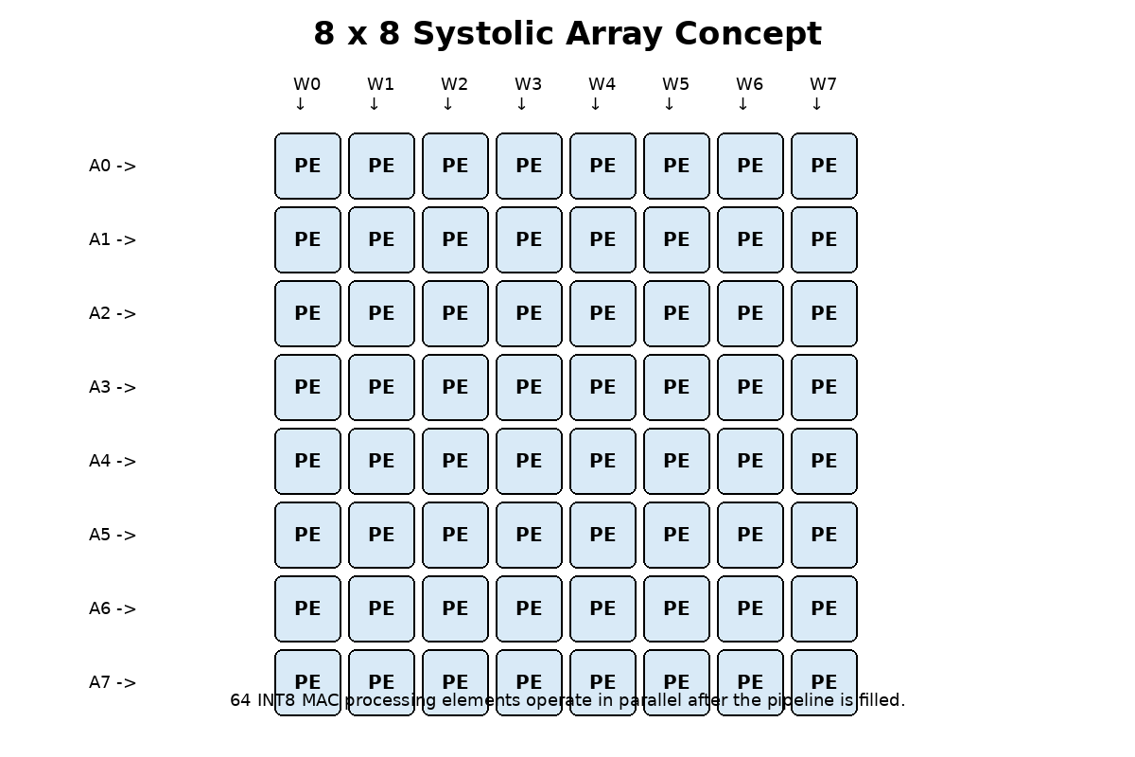
Fig 3.1 8x8 systolic array architecture
3.2 Processing Element Design
The PE is the basic computational unit of the systolic array. It receives an activation input and a weight input, performs signed multiplication, and accumulates the product into a 32-bit accumulator. The PE also forwards activation and weight values to neighboring PEs so that data can propagate through the array.
In the baseline PE, the product of the activation and weight is directly added to the accumulator in the same clock cycle. This creates a long combinational path. The longest path approximately consists of input data, signed multiplier, sign extension, 32-bit adder, and accumulator register setup time. This path determines the minimum possible clock period.
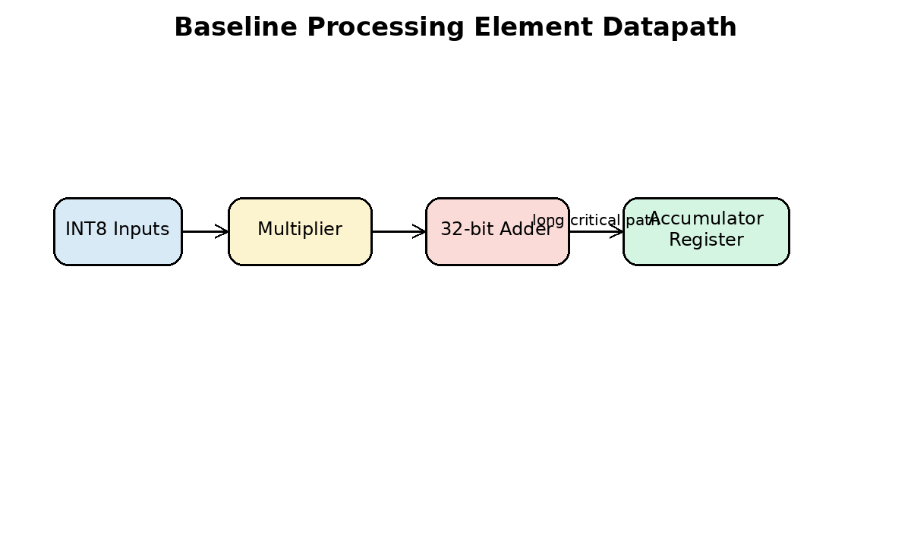
Fig 3.2 Baseline processing element datapath
3.3 8x8 Systolic Array Structure
The systolic_array_8x8 module instantiates 64 processing elements. Activations are applied to the left side of the array and weights are applied to the top side. Data moves from one PE to the next on every clock cycle. Each PE calculates a partial sum based on the data it receives.
The array has a regular structure, which simplifies design and physical implementation. Since the same PE is repeated, the array is modular and scalable. In a larger design, the same idea could be extended to 16x16 or 32x32 arrays, although area and routing complexity would increase.
The baseline array requires a fixed number of compute cycles to complete the matrix operation and drain the results. In the proposed design, one additional cycle is required because of the new pipeline register introduced inside the PE.
3.4 Register Interface and Control
The accelerator includes a simple control and register interface. The register block allows a host or testbench to configure the accelerator, load data, start computation, and read status. Important signals include start, done, clear, compute enable, and configuration cycle count.
The top module maintains compatibility with the existing interface wherever possible. This is useful because the same testbench and synthesis flow can be reused with minor updates. The design is suitable for integration into a larger SoC using a memory-mapped interface.
3.5 Limitations of Existing System
The major limitation of the baseline system is timing performance. Since multiplication and accumulation are performed in the same clock cycle, the PE critical path is long. When the clock period is reduced, the design may fail timing during synthesis or physical implementation.
Another limitation is that the long combinational path affects all PEs. Since there are 64 PEs in the 8x8 array, the timing behavior of the PE is critical for the complete accelerator. Improving the PE critical path is therefore an effective strategy for improving the overall design.
The baseline design is functionally correct for matrix multiplication, but it is not optimized for high-frequency operation. Therefore, the proposed work focuses on performance optimization rather than changing the external functionality of the accelerator.
Parameter | Baseline Design Description
Array size | 8 rows x 8 columns
Number of PEs | 64
Operand precision | Signed INT8 activations and weights
Accumulator precision | 32-bit
Main operation | Multiply-accumulate
Critical path | Multiplier plus accumulator adder
Primary limitation | Lower maximum operating frequency due to long MAC path

CHAPTER 4
METHODOLOGY
4.1 Proposed Pipelined Design Approach
The proposed methodology improves the baseline accelerator by modifying the processing element. A pipeline register is inserted at the output of the multiplier. The registered product is accumulated in the next stage. As a result, the multiplier delay and the accumulator adder delay are separated across two clock cycles.
The proposed PE has two main computation stages. In the first stage, signed INT8 operands are multiplied and the product is stored in a product pipeline register. In the second stage, the registered product is sign-extended and added to the accumulator. This approach reduces the critical path and improves timing performance.
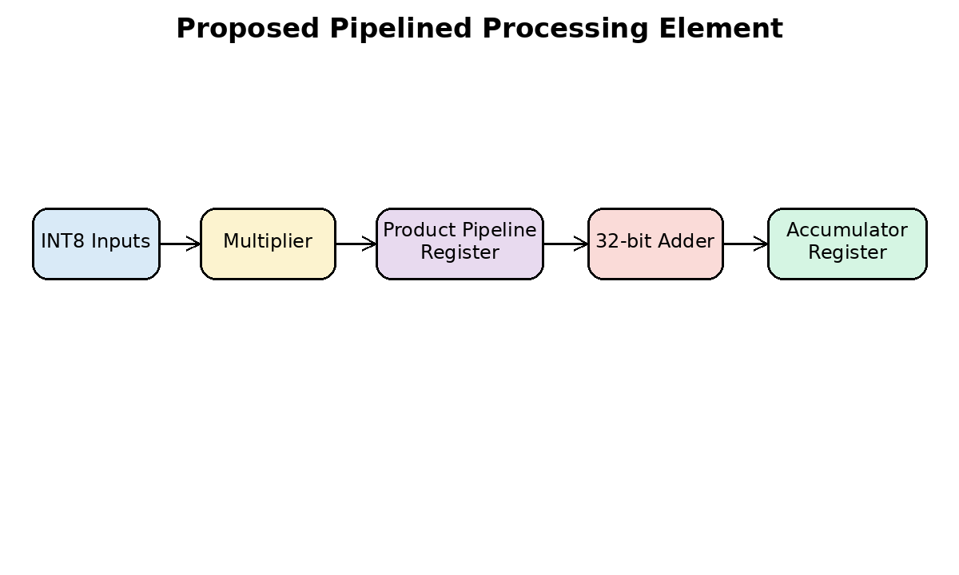
Fig 4.1 Proposed pipelined processing element
4.2 Critical Path Analysis
Critical path analysis is the first step in performance optimization. The critical path is the longest timing path between two sequential elements. In the baseline PE, the critical path includes multiplication and accumulation in one clock cycle. This path limits the minimum clock period.
After pipelining, the critical path is split into two smaller paths. The first path includes input register to multiplier and product register. The second path includes product register to accumulator adder and accumulator register. Since each path is shorter than the original combined path, the clock period can be reduced.
The expected timing improvement should be verified using Synopsys report_timing after synthesis and after physical implementation. The final result must be based on actual reported slack and critical path delay.
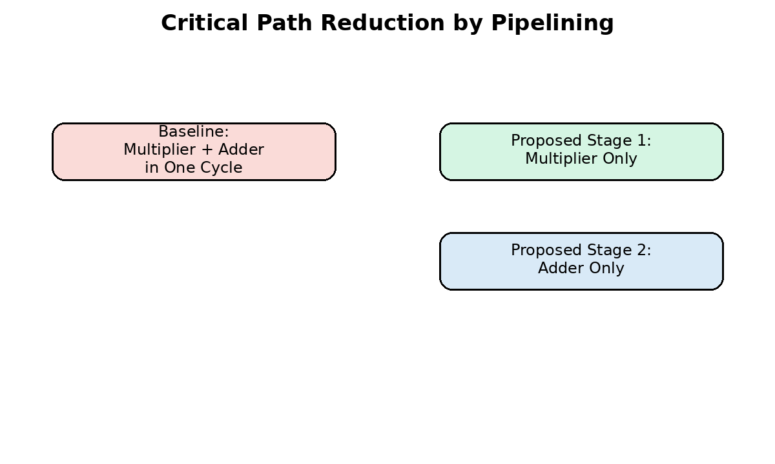
Fig 4.2 Critical path reduction by pipelining
4.3 Pipelined Processing Element
The proposed processing element keeps the same basic function as the baseline PE. It still performs signed INT8 multiplication and 32-bit accumulation. The main difference is the addition of a pipeline register called product_pipe. This register stores the multiplication result before it is added to the accumulator.
The RTL behavior can be described as follows. When compute_en is active, the product of a_in and w_in is calculated and stored in product_pipe. During the next cycle, product_pipe is added to the accumulator. The output partial sum is then available from the accumulator register.
Because the product is delayed by one clock cycle, the systolic array control must allow one additional computation cycle to flush the pipeline. Therefore, the compute cycle count is updated from the baseline value to include the extra pipeline latency.
// Conceptual proposed PE datapath
always @(posedge clk or negedge rst_n) begin
if (!rst_n) begin
product_pipe <= 16'sd0;
acc <= 32'sd0;
end else if (clear) begin
product_pipe <= 16'sd0;
acc <= 32'sd0;
end else if (compute_en) begin
product_pipe <= a_in * w_in; // Stage 1
acc <= acc + product_pipe; // Stage 2
end
end
4.4 Array-Level Timing Modification
The systolic array must be modified to account for the additional latency introduced by the PE pipeline. If the original array required 22 compute cycles, the pipelined version requires 23 compute cycles. The extra cycle allows the last valid product stored in the pipeline register to be accumulated correctly.
This change is important for functional correctness. Without updating the compute cycle count, the accelerator may stop one cycle early and produce incomplete results. Therefore, the register configuration and control logic are updated to use the proposed compute cycle count.
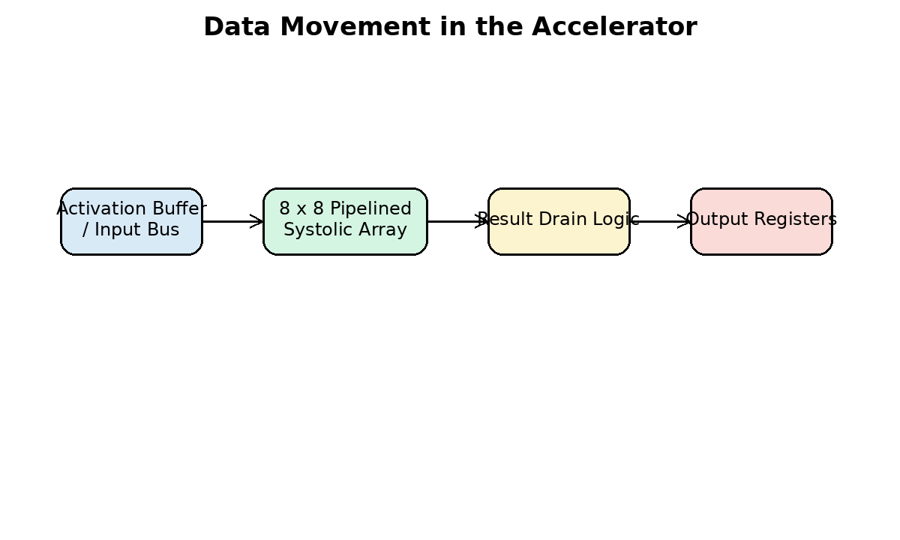
Fig 4.3 Accelerator data movement
4.5 RTL Verification Methodology
Functional verification is performed using Verilog testbenches. The PE testbench checks multiplication, accumulation, clear operation, and pipeline behavior. The systolic-array testbench checks matrix multiplication operation across the 8x8 array. The top-level testbench checks register control, start signal, done signal, and result output.
The expected output timing must account for the extra pipeline stage. The numerical result should remain the same as the baseline design, but the valid output appears one cycle later. Therefore, the testbench includes timing adjustments for the proposed design.
Verification should be performed before synthesis. A design that does not pass functional simulation should not be synthesized. After synthesis, gate-level simulation can also be performed if the library and SDF data are available.
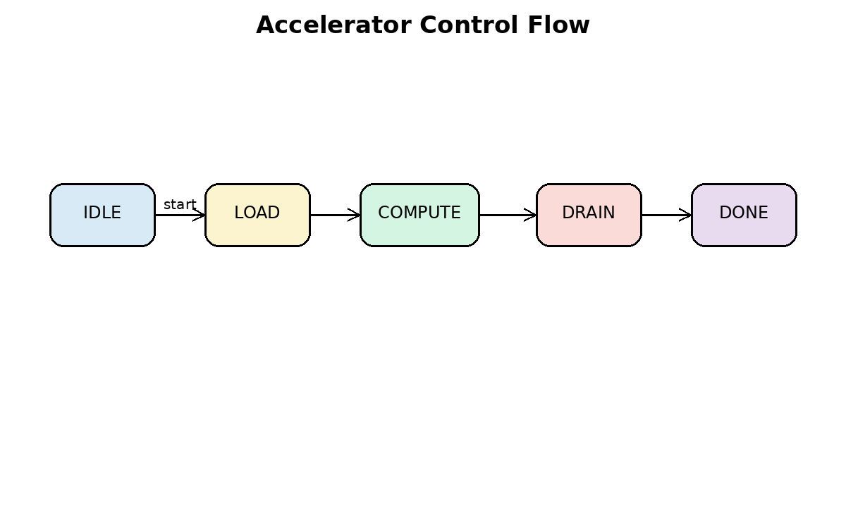
Fig 4.4 Accelerator control flow
4.6 SDC Constraint Methodology
The Synopsys Design Constraints file defines the timing environment for synthesis and physical design. The most important constraint is the clock period. For this project, a 2 ns clock period may be used as an initial target, corresponding to 500 MHz. The final achievable frequency must be determined from timing reports.
Other important constraints include input delay, output delay, clock uncertainty, reset false path, maximum transition, maximum fanout, and output load. These constraints help the synthesis and physical design tools optimize the design under realistic assumptions.
create_clock -name clk -period 2.000 [get_ports clk]
set_clock_uncertainty 0.100 [get_clocks clk]
set_input_delay 0.300 -clock clk [remove_from_collection [all_inputs] [get_ports clk]]
set_output_delay 0.300 -clock clk [all_outputs]
set_false_path -from [get_ports rst_n]
set_max_transition 0.100 [current_design]
set_max_fanout 16 [current_design]
4.7 Design Compiler Methodology
Synopsys Design Compiler is used for logic synthesis. It reads Verilog RTL and maps the design to a 32-nm standard-cell library. The output of synthesis is a gate-level netlist along with area, timing, power, and QoR reports.
The DC flow consists of setting libraries, reading RTL, elaborating the top module, linking the design, reading constraints, checking the design, compiling with optimization, and writing output files. Both baseline and proposed designs should be synthesized with the same constraints so that the comparison is fair.
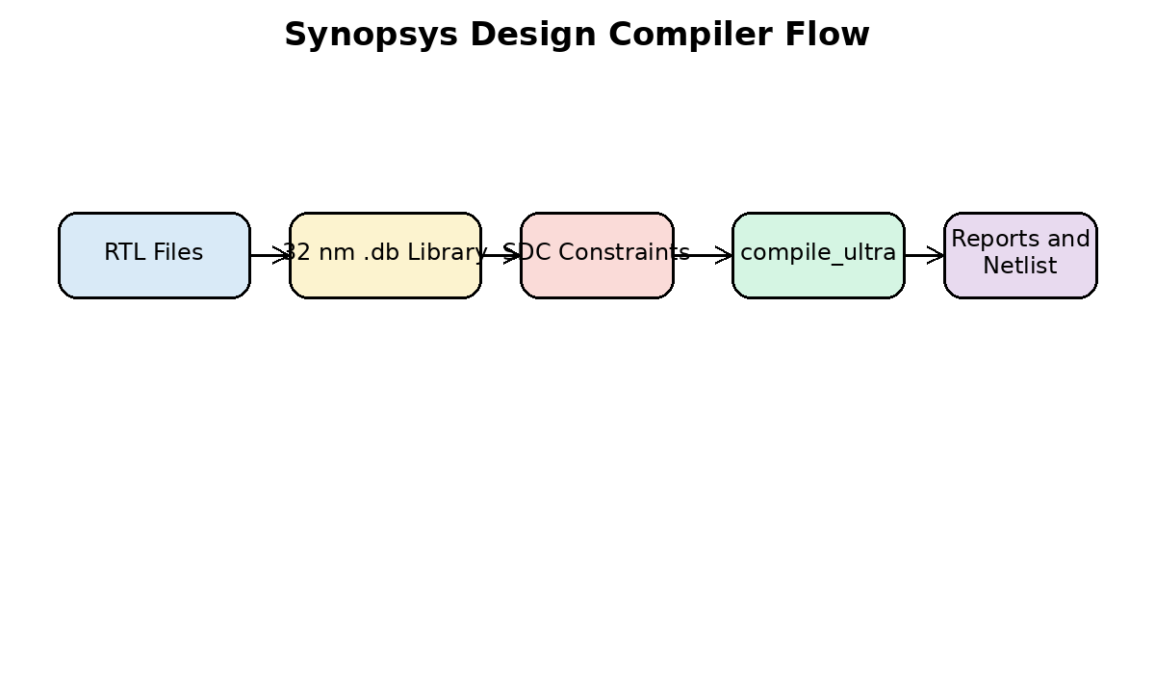
Fig 4.5 Design Compiler flow
4.8 ICC2 Physical Design Methodology
Synopsys ICC2 is used for physical implementation. It converts the synthesized netlist into a physical layout. The physical design flow includes floorplanning, power planning, placement, clock tree synthesis, routing, post-route optimization, and GDSII generation.
Physical implementation is important because synthesis results alone do not include complete routing effects. After placement and routing, timing can change due to wire delays, clock tree insertion delay, congestion, and parasitic effects. Therefore, post-layout timing and power reports are necessary for final evaluation.
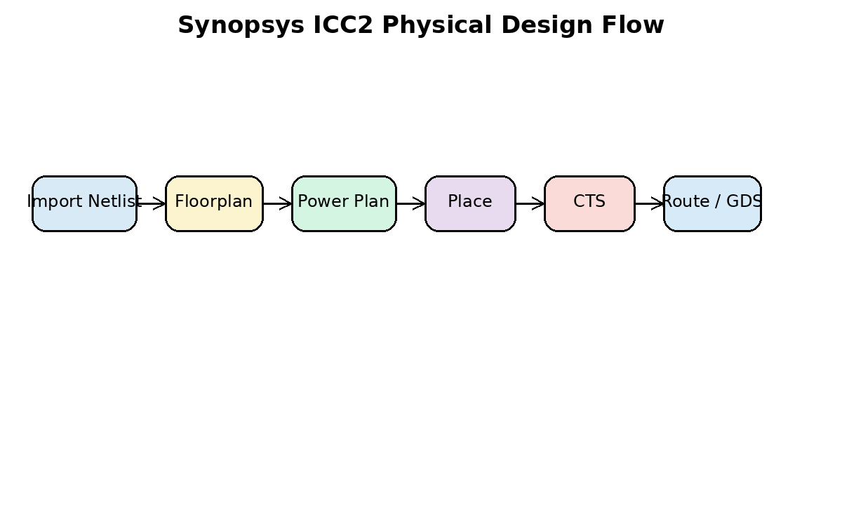
Fig 4.6 ICC2 physical design flow
4.9 Power, Performance and Area Methodology
The proposed project is evaluated using PPA metrics. Performance is measured using critical path delay, worst negative slack, and maximum frequency. Area is measured using combinational area, sequential area, and total cell area. Power is measured using dynamic power, leakage power, and total power.
The proposed design is expected to improve performance, but it may increase sequential area due to additional registers. This is a normal area-performance trade-off in pipelined digital systems.
4.10 Fair Comparison Method
A fair comparison requires that the baseline and proposed designs use the same technology library, same top module constraints, same clock period, same input/output delay assumptions, and same synthesis effort. Only then can the improvement be attributed to the proposed pipelined PE architecture.
Reports should be generated for both versions. The values must be copied directly from Synopsys reports without modification. Estimated or assumed values should not be used in the final result section.
4.11 Verification Checklist
The verification checklist includes reset behavior, clear behavior, compute enable behavior, correct product generation, correct accumulation, correct done signal generation, and correct result drain timing. All tests must pass before the design is considered ready for synthesis.
Waveform screenshots may be included in the final documentation. The most useful screenshots are clock and reset, compute enable, product pipeline register, accumulator output, done signal, and final result bus.
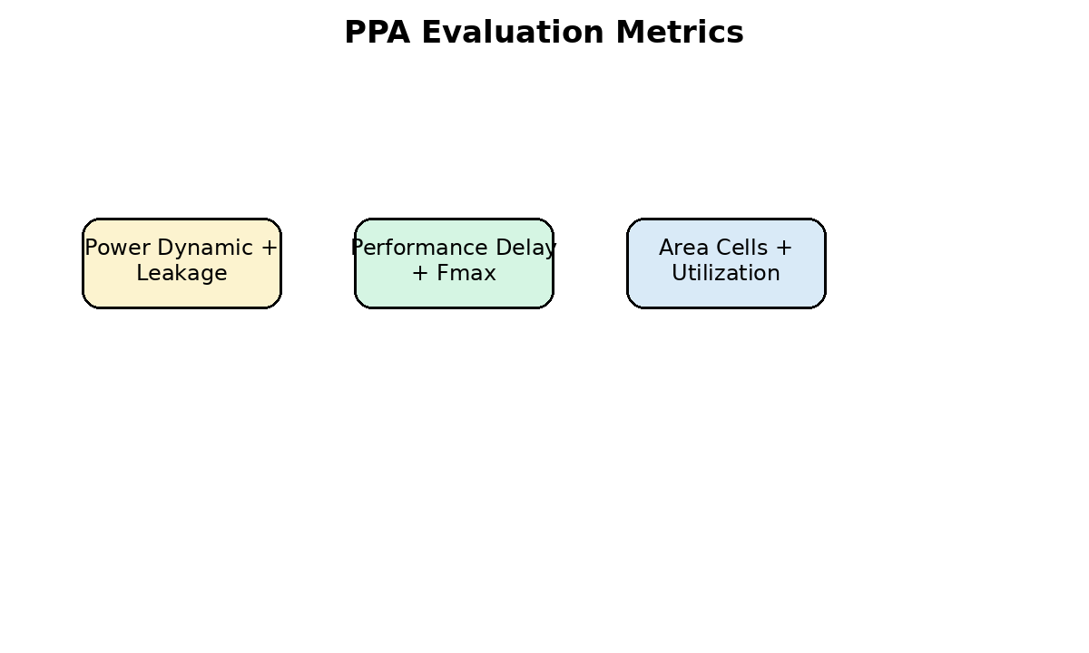
Fig 4.7 Power, performance and area metrics

CHAPTER 5
IMPLEMENTATION
5.1 RTL Files Used
The RTL implementation is organized into separate Verilog files. This modular approach improves readability and simplifies debugging. The main modified files are systolic_pe.v and systolic_array_8x8.v. The register interface and top-level files are kept compatible with the original design wherever possible.
The systolic_pe.v file contains the proposed pipelined PE logic. The systolic_array_8x8.v file instantiates 64 PEs and connects them in a systolic structure. The accel_regs.v file contains control and status registers. The accel_top.v file integrates the register interface and array datapath.
File Name | Purpose | Modification
systolic_pe.v | Processing element with INT8 MAC | Product pipeline register added
systolic_array_8x8.v | 8x8 PE array | Compute cycle count updated
accel_regs.v | Configuration and status registers | Default config cycle updated
accel_top.v | Top-level accelerator | Interface retained
soc_top.v | System-level wrapper | Used for integration study
cpu_bfm.v | Bus functional model | Used in top-level testbench

5.2 Testbench Files Used
Testbenches are used to verify the functionality of the modified RTL. The PE testbench verifies the basic MAC operation and pipeline latency. The array testbench verifies the complete 8x8 matrix multiplication operation. The top-level testbench verifies start, control, and done behavior.
Simulation should be performed using any available Verilog simulator such as VCS, ModelSim, Xcelium, or Icarus Verilog for smoke testing. The testbench must account for the additional one-cycle pipeline latency.
Testbench | Verification Target | Expected Check
tb_systolic_pe.v | Single processing element | Product and accumulator correctness
tb_systolic_array_8x8.v | Complete array | Matrix multiplication result
tb_accel_top.v | Top-level accelerator | Register control and done status

5.3 DC Script Implementation
The run_dc.tcl script automates logic synthesis. The user must update library paths according to the 32-nm standard-cell library available in the laboratory. The target library, link library, synthetic library, and search path must be set correctly before running synthesis.
The script reads RTL, elaborates accel_top, reads the SDC file, checks constraints, compiles the design, and writes reports. The generated reports should be saved separately for the baseline and proposed designs.
# Important steps in run_dc.tcl
set TOP accel_top
set_app_var target_library $TARGET_LIB
set_app_var link_library "* $TARGET_LIB $LINK_LIBS"
read_verilog $RTL_FILES
elaborate $TOP
link
read_sdc ../constraints/accel_top_32nm.sdc
check_design
compile_ultra
report_timing > reports/timing.rpt
report_area > reports/area.rpt
report_power > reports/power.rpt
write -format verilog -hierarchy -output outputs/${TOP}_mapped.v
write_sdc outputs/${TOP}_mapped.sdc
5.4 ICC2 Script Implementation
The run_icc2.tcl script performs physical implementation. The user must update the technology file, reference libraries, and GDS map file according to the available 32-nm physical library. ICC2 uses these files to create the design library and perform placement and routing.
The script imports the synthesized netlist, reads SDC constraints, creates a floorplan, creates power and ground connections, performs placement, clock-tree synthesis, routing, and writes the final layout data. Actual commands may vary depending on the library setup used in the laboratory.
# Important steps in run_icc2.tcl
create_lib -technology $TECH_FILE -ref_libs $REF_LIBS work/${TOP}.dlib
read_verilog ../syn/outputs/${TOP}_mapped.v
current_design $TOP
link_block
read_sdc ../syn/outputs/${TOP}_mapped.sdc
initialize_floorplan -core_utilization 0.65 -core_offset {5 5 5 5}
place_opt
clock_opt
route_auto
route_opt
report_timing > reports/post_route_timing.rpt
report_power > reports/post_route_power.rpt
write_gds -output outputs/${TOP}.gds
5.5 Checks after Implementation
- Check that the RTL simulation passes for all testbenches.
- Check that Design Compiler reports no unresolved references.
- Check that setup and hold timing reports are generated.
- Check that area and power reports are saved for both baseline and proposed designs.
- Check that ICC2 placement has acceptable utilization.
- Check that clock tree synthesis completes without major violations.
- Check that routing completes without serious DRC violations.
- Check that final GDSII is generated successfully.

CHAPTER 6
RESULTS AND DISCUSSION
6.1 Result Parameters
The final results of the project should be obtained from Synopsys reports. The baseline and proposed designs must be compared using the same constraints and library. The most important parameters are area, timing, power, and physical design metrics.
Since actual Synopsys reports depend on the 32-nm library and tool setup used in the laboratory, placeholder tables are provided in this document. These placeholders must be replaced with actual values after running Design Compiler and ICC2.
6.2 Synthesis Results
Parameter | Baseline Design | Proposed Pipelined Design | Observation
Total cell area | To be filled | To be filled | Compare overall area
Combinational area | To be filled | To be filled | Logic area comparison
Sequential area | To be filled | To be filled | Proposed may increase
Dynamic power | To be filled | To be filled | Compare switching power
Leakage power | To be filled | To be filled | Compare leakage
Total power | To be filled | To be filled | Power trade-off
Critical path delay | To be filled | To be filled | Proposed should reduce
Maximum frequency | To be filled | To be filled | Proposed should improve
WNS | To be filled | To be filled | Timing slack comparison
TNS | To be filled | To be filled | Overall timing violation comparison

6.3 Physical Design Results
Parameter | Baseline Design | Proposed Pipelined Design | Observation
Core area | To be filled | To be filled | Layout area comparison
Core utilization | To be filled | To be filled | Placement density
Standard-cell count | To be filled | To be filled | Cell count comparison
Setup WNS | To be filled | To be filled | Post-route setup timing
Hold WNS | To be filled | To be filled | Post-route hold timing
Clock latency | To be filled | To be filled | CTS quality
Clock skew | To be filled | To be filled | CTS balance
Total power | To be filled | To be filled | Post-layout power
Routed wire length | To be filled | To be filled | Routing comparison
GDS generated | Yes/No | Yes/No | Final output

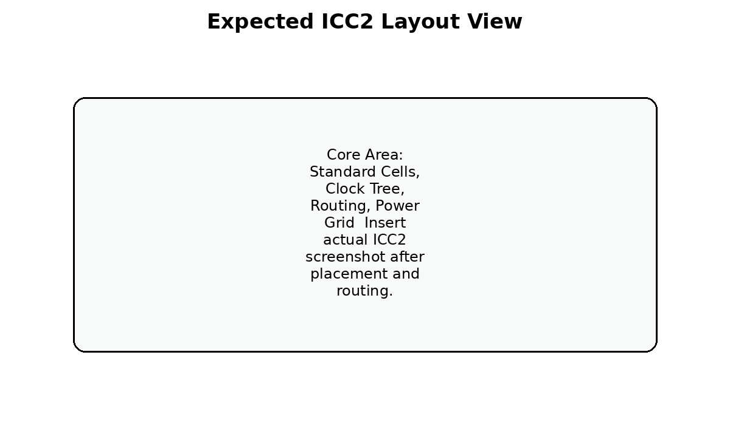
Fig 6.1 Expected ICC2 layout view
6.4 Baseline vs Proposed Comparison
The proposed pipelined design is expected to reduce the critical path delay compared with the baseline design. The improvement occurs because multiplication and accumulation no longer share the same combinational timing path. The maximum operating frequency should therefore increase.
The expected trade-off is an increase in sequential area due to the new pipeline registers. Dynamic power may also change due to additional register switching. However, the main objective of this project is high performance, so this trade-off is acceptable if the timing improvement is significant.
The final discussion should be based on the actual numbers generated by Design Compiler and ICC2. If the proposed design improves WNS and maximum frequency with a reasonable area overhead, the project objective is achieved.
6.5 Reports to be Inserted
- Design Compiler report_area screenshot or text summary.
- Design Compiler report_timing screenshot showing critical path.
- Design Compiler report_power screenshot.
- ICC2 floorplan screenshot.
- ICC2 placement screenshot.
- ICC2 CTS clock tree or clock report screenshot.
- ICC2 routing screenshot.
- Post-route timing report.
- Final GDSII layout screenshot.

CHAPTER 7
CONCLUSION
7.1 Summary
This project presents the design and 32-nm physical implementation of a high-performance pipelined INT8 systolic-array AI accelerator. The accelerator is based on an 8x8 systolic array containing 64 processing elements. Each processing element performs signed INT8 multiplication and 32-bit accumulation for matrix-multiplication-based machine-learning workloads.
The baseline design has a long critical path because the multiplier and accumulator adder are present in the same combinational path. To improve timing performance, the proposed design inserts a pipeline register between the multiplication stage and the accumulation stage. This modification splits the MAC datapath into two stages and reduces the critical path delay.
The design is implemented in Verilog HDL and verified using testbenches. It is synthesized using Synopsys Design Compiler with a 32-nm standard-cell library and physically implemented using Synopsys ICC2. The final results are evaluated using area, power, timing, utilization, and post-route layout metrics.
7.2 Future Scope
The project can be extended in several directions. The current 8x8 systolic array can be scaled to 16x16 or larger arrays to increase throughput. Multi-precision operation can be added to support INT4 and INT8 modes. On-chip SRAM buffers can be included to reduce input-output bandwidth requirements. A standard bus interface such as AXI or APB can be added for SoC integration.
Further work can also include clock gating for low-power operation, formal verification, post-layout simulation using SDF, and integration with a RISC-V processor. CNN-specific frontend logic such as im2col data generation can also be added to support convolution acceleration directly.
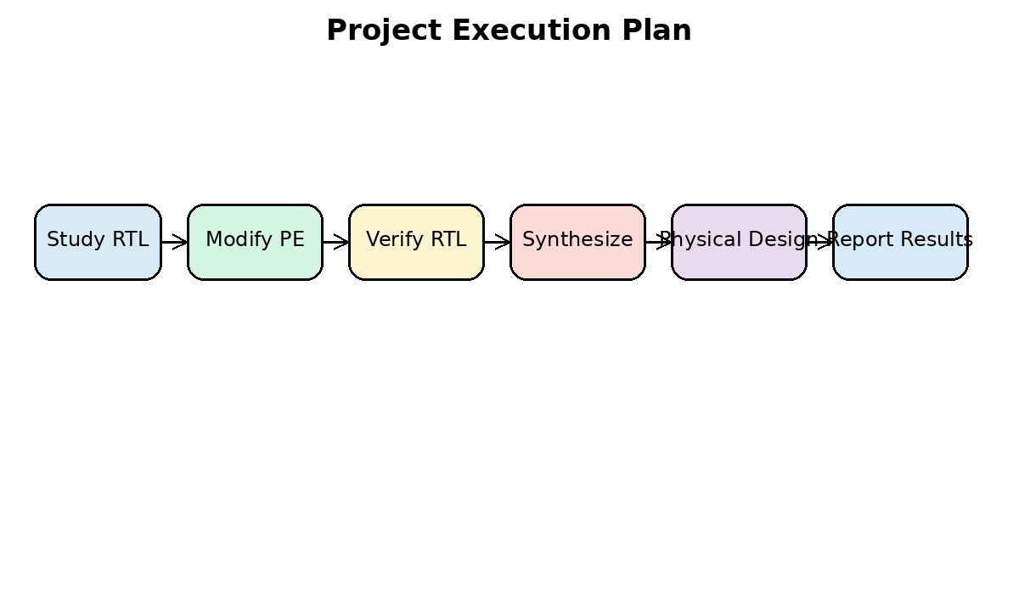
Fig 7.1 Project execution plan

REFERENCES
[1] Kashif Inayat and Jaeyong Chung, “Hybrid Accumulator Factored Systolic Array for Machine Learning Acceleration,” IEEE Transactions on Very Large Scale Integration (VLSI) Systems, vol. 30, no. 7, pp. 881-892, July 2022.
[2] H. T. Kung, “Why Systolic Architectures?” Computer, vol. 15, no. 1, pp. 37-46, 1982.
[3] N. P. Jouppi et al., “In-Datacenter Performance Analysis of a Tensor Processing Unit,” Proceedings of the 44th Annual International Symposium on Computer Architecture, 2017.
[4] Synopsys, Design Compiler User Guide.
[5] Synopsys, IC Compiler II Implementation User Guide.
[6] J. Bhasker and R. Chadha, Static Timing Analysis for Nanometer Designs: A Practical Approach.
[7] IEEE Standard for Verilog Hardware Description Language.
[8] M. S. Lam, “Software pipelining: An effective scheduling technique for VLIW machines,” ACM SIGPLAN, 1988.
[9] S. Mittal, “A survey of FPGA-based accelerators for convolutional neural networks,” Neural Computing and Applications, 2020.
[10] D. Patterson and J. Hennessy, Computer Organization and Design: The Hardware/Software Interface.

APPENDIX
Appendix A: Files Used in the Project
Category | Files
RTL | systolic_pe.v, systolic_array_8x8.v, accel_regs.v, accel_top.v, soc_top.v, cpu_bfm.v
Testbench | tb_systolic_pe.v, tb_systolic_array_8x8.v, tb_accel_top.v
Constraints | accel_top_32nm.sdc
Scripts | run_dc.tcl, run_icc2.tcl, run_iverilog_smoke.sh
Reports | area.rpt, timing.rpt, power.rpt, qor.rpt, post_route_timing.rpt, post_route_power.rpt

Appendix B: Important Design Commands
# Simulation smoke test
iverilog -g2012 -o simv rtl/*.v tb/tb_systolic_array_8x8.v
vvp simv
# Design Compiler
mkdir -p syn/reports syn/outputs
cd syn
dc_shell -f ../scripts/run_dc.tcl | tee dc.log
# ICC2
mkdir -p pnr/reports pnr/outputs
cd pnr
icc2_shell -f ../scripts/run_icc2.tcl | tee icc2.log
Appendix C: One-Minute Explanation for Viva
This project designs a high-performance INT8 AI accelerator based on an 8x8 systolic array. The accelerator performs matrix multiplication using 64 processing elements. Each processing element performs signed 8-bit multiplication and 32-bit accumulation. In the baseline design, the multiplier and accumulator are present in the same clock path, which limits the maximum frequency.
The proposed design improves timing by adding a pipeline register between the multiplier and the accumulator. This reduces the critical path delay and increases the achievable operating frequency. The RTL is verified using testbenches, synthesized using Synopsys Design Compiler, and physically implemented using Synopsys ICC2 in 32-nm technology. The baseline and proposed designs are compared using area, power, timing, and layout reports.
Appendix D: Final Submission Checklist
- Replace [STUDENT NAME], [REGISTRATION NUMBER], [GUIDE NAME], and [DATE].
- Insert actual simulation waveform screenshots.
- Insert actual Design Compiler area, timing, power, and QoR reports.
- Insert actual ICC2 floorplan, placement, CTS, routing, and GDS screenshots.
- Fill all result tables using actual values from reports.
- Check references and base paper details.
- Verify final formatting, page numbers, and figure captions before printing.
Appendix E: Notes on Result Interpretation
If the proposed design shows higher maximum frequency but slightly higher area, the result is valid because the project objective is high performance. A pipelined design normally uses extra registers, which increases sequential area. The improvement must be explained as an area-performance trade-off.
If the proposed design has higher dynamic power, the reason may be additional flip-flop switching. This does not invalidate the project because the goal is not low-power optimization. However, the power increase should be reported honestly and discussed clearly.
If the post-route timing is worse than synthesis timing, the reason is routing parasitic delay and clock tree insertion delay. This is normal in physical design. The final conclusion should preferably use post-route reports because they are closer to the actual implemented layout.

ADDITIONAL APPENDICES
The following appendices are added to support the final project documentation, viva preparation, and tool execution. These sections follow the same report style and can be retained in the final dissertation or removed based on department guidelines.
Appendix F: Detailed RTL Module Description
The RTL design is divided into multiple modules so that each part of the accelerator can be verified and modified independently. This modular structure is important in VLSI design because debugging a large monolithic design is difficult. The processing element is kept as an independent module and instantiated multiple times inside the systolic array.
The systolic_pe module is the lowest-level arithmetic block. It receives signed 8-bit activation and weight values and produces a 32-bit accumulated partial sum. In the proposed design, the multiplication output is stored in a product pipeline register. This register divides the MAC datapath into two smaller timing stages.
The systolic_array_8x8 module creates the array by instantiating 64 processing elements. The interconnection between processing elements provides the systolic movement of data. Activations move horizontally, weights move vertically, and each processing element accumulates a local result. The array-level control enables load, compute, and drain phases.
The accel_regs module provides configuration and status control. It is responsible for storing start bits, configuration cycles, status flags, and other control information. In the proposed design, the default compute cycle count is updated to support the additional pipeline latency.
The accel_top module integrates the register interface and systolic array. It is the primary synthesis top module for Design Compiler. Keeping the top-level interface stable is useful because the same synthesis and physical design flow can be used for both baseline and proposed designs.
Module | Inputs / Outputs | Role in Design | Important Note
systolic_pe | clk, rst_n, clear, load_w, compute_en, a_in, w_in, a_out, w_out, psum_out | Performs signed INT8 multiply and 32-bit accumulation | Contains product pipeline register in proposed design
systolic_array_8x8 | Clock, reset, input data, control signals, output results | Connects 64 PEs into an 8x8 systolic array | Compute cycle count is increased by one
accel_regs | Bus/control interface signals | Stores configuration, start, done, and control values | Default cycles updated for pipelined PE
accel_top | External accelerator interface | Top-level module for synthesis | Used as TOP in run_dc.tcl and run_icc2.tcl
soc_top | System wrapper signals | Optional system-level integration | Useful for demonstration only

Appendix G: Detailed Timing Explanation
Timing analysis is essential in this project because the main objective is performance improvement. The baseline design has a critical path that passes through both multiplication and addition. This path must satisfy the clock period constraint. If the path delay is greater than the clock period after considering setup time and uncertainty, setup violation occurs.
The proposed design reduces setup timing pressure by adding a pipeline register after multiplication. This changes one long path into two shorter paths. The first path ends at the product pipeline register, and the second path ends at the accumulator register. The clock period is now limited by the maximum delay of these two shorter paths rather than the combined multiplier-adder path.
In Design Compiler, the timing report should be checked using report_timing. The most important fields are data arrival time, data required time, and slack. Positive slack means the design meets timing for that path. Negative slack means timing violation. The proposed design should show better worst negative slack or a lower critical path delay compared with the baseline design.
In ICC2, timing must be checked again after placement, CTS, and routing. Post-route timing is more realistic because it includes wire delay and clock tree effects. A design that passes synthesis timing may still fail after routing if interconnect delay is high. Therefore, the final conclusion should give more importance to post-route timing.
Timing Term | Meaning | Use in Project
Clock period | Time available for one clock cycle | Used to define frequency target
Critical path | Longest register-to-register path | Main path to be reduced by pipelining
Setup slack | Required time minus arrival time | Positive value indicates setup timing is met
Hold slack | Minimum delay timing margin | Must be checked after CTS and routing
WNS | Worst negative slack | Primary timing quality indicator
TNS | Total negative slack | Shows overall timing violation severity
Fmax | Maximum clock frequency | Calculated as 1 / critical path delay

Appendix H: Synthesis Report Collection Procedure
After running Design Compiler, the reports directory must be checked carefully. The most important reports are area, timing, power, constraint, and QoR reports. These reports provide the values that must be entered in the result tables of Chapter 6.
The area report gives total cell area, combinational area, and sequential area. The proposed pipelined design is expected to show an increase in sequential area because additional flip-flops are inserted. The combinational area may remain similar because the multiplier and adder functions are not fundamentally changed.
The timing report gives the longest path delay and slack. The proposed design is expected to show improved timing because the multiplier and adder are separated. The power report gives dynamic and leakage power. The proposed design may show a small power increase because more registers are switching.
The QoR report provides a compact summary of timing, area, power, and design rule violations. It is useful for quickly comparing baseline and proposed versions. The student should preserve both raw reports and screenshots for final documentation.
Report File | Command | Information to Extract
area.rpt | report_area | Total area, combinational area, sequential area
timing.rpt | report_timing | Critical path delay, WNS, startpoint, endpoint
power.rpt | report_power | Dynamic power, leakage power, total power
qor.rpt | report_qor | Overall synthesis quality summary
constraints.rpt | report_constraints | Unmet timing and design constraints
clock_gating.rpt | report_clock_gating | Only needed if clock gating is enabled

Appendix I: Physical Design Report Collection Procedure
The ICC2 physical design flow produces reports and layout views at different stages. Important stages include floorplan, placement, clock-tree synthesis, routing, and post-route optimization. Screenshots from these stages should be inserted into the final result chapter.
The floorplan screenshot should show core boundary, standard-cell area, input-output pin placement, and power planning if available. The placement screenshot should show standard-cell placement density. The CTS screenshot or report should show that the clock network has been built. The routing screenshot should show the completed routed design.
Post-route timing and power reports are important because they include layout effects. The final GDSII output proves that the RTL-to-GDSII design flow has been completed. The design may require iterations if there are setup, hold, transition, capacitance, or routing violations.
ICC2 Stage | Command / Activity | Output for Report
Floorplan | initialize_floorplan | Core area and utilization screenshot
Power planning | create power/ground network | Power grid screenshot if available
Placement | place_opt | Placement utilization and congestion report
CTS | clock_opt | Clock latency and skew report
Routing | route_auto and route_opt | Routed layout screenshot
Post-route signoff | report_timing, report_power | Final timing and power values
Export | write_gds | Final GDSII file

Appendix J: Result Calculation Examples
Maximum operating frequency is calculated from the critical path delay. If the critical path delay is given in nanoseconds, the frequency in MHz can be calculated as 1000 divided by the delay in nanoseconds. For example, if the critical path delay is 2 ns, the maximum frequency is 500 MHz.
Percentage improvement can be calculated by comparing baseline and proposed values. For frequency improvement, the difference between proposed frequency and baseline frequency is divided by baseline frequency and multiplied by 100. For delay reduction, the difference between baseline delay and proposed delay is divided by baseline delay and multiplied by 100.
Area overhead is calculated by subtracting baseline area from proposed area, dividing by baseline area, and multiplying by 100. This value explains the cost of adding pipeline registers. These calculations should be performed using actual report values.
Fmax (MHz) = 1000 / Critical path delay (ns)
Frequency improvement (%) = ((Fmax_proposed - Fmax_baseline) / Fmax_baseline) x 100
Delay reduction (%) = ((Delay_baseline - Delay_proposed) / Delay_baseline) x 100
Area overhead (%) = ((Area_proposed - Area_baseline) / Area_baseline) x 100
Appendix K: Viva Questions and Answers
Q: What is the main aim of your project?
A: The main aim is to improve the timing performance of an 8x8 INT8 systolic-array AI accelerator by introducing a pipelined processing element and implementing the design using Synopsys DC and ICC2 in 32-nm technology.
Q: What is a systolic array?
A: A systolic array is a regular grid of processing elements where data moves rhythmically between neighboring elements. It is suitable for matrix multiplication because many MAC operations can be performed in parallel.
Q: Why did you use INT8?
A: INT8 arithmetic is commonly used in machine-learning inference because it reduces area and improves speed compared with floating-point arithmetic while maintaining acceptable accuracy for many workloads.
Q: What is the critical path in the baseline PE?
A: The baseline critical path contains the INT8 multiplier, sign extension logic, 32-bit adder, and accumulator register setup time.
Q: What is your proposed modification?
A: A product pipeline register is inserted between the multiplier and accumulator. This separates multiplication and accumulation into two pipeline stages.
Q: What is the advantage of pipelining?
A: Pipelining reduces the delay of each clock stage and improves maximum operating frequency.
Q: What is the trade-off of pipelining?
A: The trade-off is additional sequential area, possible increase in power, and one extra latency cycle.
Q: Which tools are used?
A: Verilog HDL is used for RTL design, Synopsys Design Compiler is used for synthesis, and Synopsys ICC2 is used for physical design.
Q: What results are compared?
A: Area, dynamic power, leakage power, total power, critical path delay, maximum frequency, WNS, TNS, utilization, and post-route timing are compared.
Q: Is this a low-power project?
A: No. This project focuses on high-performance timing improvement through pipelining. Power is reported as part of PPA analysis but is not the main optimization target.
Appendix L: Common Mistakes to Avoid
- Do not claim low-power improvement unless actual power reduction is shown.
- Do not invent synthesis or physical design results. Use only tool-generated values.
- Do not compare baseline and proposed designs using different constraints.
- Do not forget the extra pipeline latency in the testbench.
- Do not submit only RTL simulation without DC and ICC2 reports.
- Do not use a reliability or redundant-MAC paper as the main base paper for this high-performance pipelined design.
- Do not ignore hold timing after CTS and routing.
- Do not forget to replace placeholders before final submission.
Appendix M: Final Report Insertion Points
After completing the tool flow, actual screenshots and report values should be inserted at the appropriate locations. Simulation waveforms can be placed in Chapter 5 or Chapter 6. DC reports should be placed in the synthesis result section. ICC2 screenshots should be placed in the physical design result section.
The final document should contain at least one waveform screenshot, one DC timing report screenshot, one DC area report screenshot, one DC power report screenshot, one ICC2 floorplan screenshot, one placement screenshot, one routing screenshot, and one final GDS screenshot. These figures will make the report stronger and easier to defend during viva.

